Question 1/4 (5 points)
Write a method void removeEveryNth(int n) on the LinkedList class that traverses the list and (in-place) removes every n-th element .

For example, after calling removeEveryNth(3) on the following list:

1 -> 2 -> 3 -> 4 -> 5 -> 6 -> 7 -> 8 -> 9 -> 10 -> 11

will result in a list containing following elements:

1 -> 2 -> 4 -> 5 -> 7 -> 8 -> 10 -> 11

Question 2/4 (6 points)
Write a method void minMaxTraverse(TreeAction action) on the binary search tree that traverses all elements in the tree interleaving the minimum and maximum elements, converging all the way to the median.

For example: for the given tree:
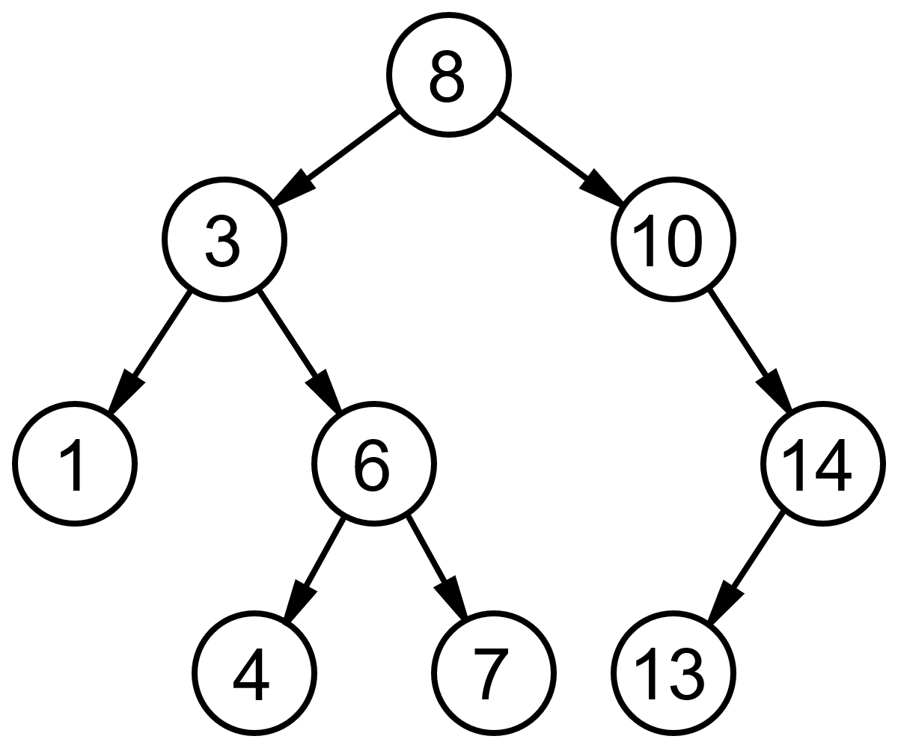
The method will traverse the elements in this order: 1, 14, 3, 13, 4, 10, 6, 8, 7
What is the time complexity of the method?

Hint: Check supplementary material, traverse() and traverseInOrder() methods might help as an inspiration.

Question 3/4 (4 points)
Assume a stack data structure contains only numbers and has push, pop, and top operations implemented in O(1). Write a method int getMax() that returns the largest element on stack in O(1) while preserving the time complexity of the other methods. You will need to change the other methods too, so please provide the updated implementation of all the methods you need to change.

Question 4/4: (5 points)
A Directed Acyclic Graph (DAG) is a directed graph that contains no cycles. Write a boolean isDAG() method on the graph to check whether a given graph is a DAG or not. You can assume the edge list representation.
What is the time complexity of the method?

Provided Code

Linked List

public class LinkedList implements Comparable{
class ListElement
{
private Comparable el1;
private ListElement el2;

public ListElement(Comparable el, ListElement nextElement)
{
el1 = el;
el2 = nextElement;
}

public ListElement(Comparable el)
{
this(el,null);
}

public Comparable first()
{
return el1;
}

public ListElement rest()
{
return el2;
}

public void setFirst(Comparable value)
{
el1 = value;
}

public void setRest(ListElement value)
{
el2 = value;
}
}

protected ListElement head;
private int count = 0;

public LinkedList()
{
head = null;
}

public String toString()
{
String result = "(";
ListElement d = head;
while(d != null)
{
result += d.first().toString();
result += " ";
d = d.rest();
}
result += ")";
return result;
}
}

Stack
public class Stack {

private LinkedList data;

public Stack()
{
data = new LinkedList();
}

public void push(Comparable o)
{
data.addFirst(o);
}

public Comparable pop()
{
if(data.empty()) return null;
else return data.removeFirst();
}

public Comparable top()
{
return data.getFirst();
}

…
}

Binary Tree

public class Tree {

public class TreeNode implements Comparable {
protected Comparable value;
protected TreeNode leftNode, rightNode;
public TreeNode(Comparable v) {
value = v;
leftNode = null;
rightNode = null;
}
public TreeNode(Comparable v, TreeNode left, TreeNode right) {
value = v;
leftNode = left;
rightNode = right;
}
public TreeNode getLeftTree() { return leftNode;}

public TreeNode getRightTree() { return rightNode; }

public Comparable getValue() { return value; }
}
protected TreeNode root;
public Tree() {
root = null;
}
public void traverseNode(TreeNode n,TreeAction action) {
if(n != null) {
if(n.getLeftTree() != null) traverseNode(n.getLeftTree(),action);
action.run(n);
if(n.getRightTree() != null) traverseNode(n.getRightTree(),action);
}
}
public void traverseInOrder(TreeAction action) {
traverseNode(root,action);
}
public void traverse(TreeAction action){
Stack t = new Stack();
t.push(root);
while(!t.empty()) {
TreeNode n = (TreeNode)t.pop();
action.run(n);
if(n.getLeftTree() != null) t.push(n.getLeftTree());
if(n.getRightTree() != null) t.push(n.getRightTree());
}
}
}

Graph
public class Graph
{
public class Node implements Comparable
{
private Comparable info;
private Vector edges;

public Node(Comparable label)
{
info = label;
edges = new Vector();
}

public void addEdge(Edge e)
{
edges.addLast(e);
}

public int compareTo(Object o){ ... }

public Comparable getLabel()
{
return info;
}
}

private class Edge implements Comparable
{
private Node toNode;

public Edge(Node to)
{
toNode = to;
}

public int compareTo(Object o){ ... }
}

private Vector nodes;

public Graph()
{
nodes = new Vector();
}

public void addNode(Comparable label)
{
nodes.addLast(new Node(label));
}

public void addEdge(Comparable nodeLabel1, Comparable nodeLabel2)
{
Node n1 = findNode(nodeLabel1);
Node n2 = findNode(nodeLabel2);
n1.addEdge(new Edge(n2));
}
}

